Image file formats
Every file on a computer is stored using a specific file format. This file format is used to attach information to a file which allows a computer to determine that type of data contained in the file.
When a file is saved, a three or four letter code is automatically attached to the file. This code identifies the file type or application used to create it. When a file is saved in an application, the default file format will be attached. This default is called the native file format.
For example, the native file format for a document created in Microsoft® Word is .doc.
It is common that only the original program can open the native file format. This is especially true for image manipulation software, however most programs can open several file formats providing the file is of a similar type, such as a word processed document or an image or sound file.
Most software applications have the ability to save a file in many, more common file formats. Some file formats can be opened on both Windows® and Macintosh® computers. These formats are said to be cross-platform. The advantage of this is that other programs can open the file. It is very important when creating any project that an appropriate file format is selected.
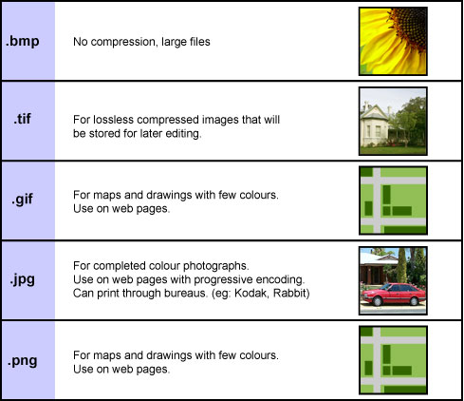

Image File Formats
JPEG File Format: (pronounced ‘jay peg’) this is a file format used for photographic and image files. JPEG is an acronym of the words Joint Photographic Expert Group. The format was developed specifically to provide a suitable format for the creation and storage of photographs and photo-realistic images. The JPEG file format is best for any images that have subtle changes in colour, lighting effects, depth or gradations of tones.
JPEG files are cross platform and can be compressed. Compression is the process of altering data to make the size of the file smaller. The compression scheme used in the JPEG format is termed ‘lossy’. This means data is actually removed from the image to decrease the size of the file. The compression scheme used for JPEG, if used correctly, can achieve very high compression ratios without any significant loss in image quality. When a JPEG image is saved, the level of compression can be selected. The higher the compression used, the smaller the file size with a greater the reduction in quality.
The lossy compression scheme used in the jpeg format is called Discrete Cosine Transform or DCT. This scheme exploits the limitations of the human eye. Small changes in colour are not as noticeable as small changes in brightness. This scheme analyses the image and breaks it into blocks of pixels. The brightness of each block of pixels is then compared, and an average colour is determined for all pixels in each block. This reduces the amount of colour data needed for every individual pixel.
The JPEG format does not compress solid areas of colour, lines or edges well. These areas can look blocky when the compression ratio is too high.
JPEG files cannot be made transparent and because all image and graphics files are rectangular, JPEG will always appear with straight edges. The great advantage of this format is its 24-bit colour depth. A JPEG file can contain 16.7 million colours making the format perfect for photographs, digital paintings and complex colour graphics.

JPEG characteristics
• Used for images that are natural, art or photographic
• Uses 24 bit colour depth – 16.7 million colours
• Great for archiving and transmitting across different media
• A lossy compression scheme that gives very high compression ratios
• Compression is cumulative; every time an image is altered JPEG sees a different image and compresses it again and again. Each compression removes data and reduces the quality of the image.

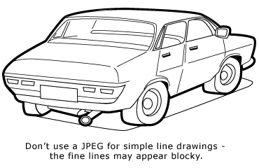

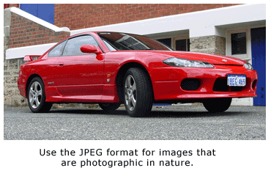

GIF format: (pronounced giff) this file format was developed especially for on-line use. The acronym stands for Graphic Interchange Format. GIF files are cross platform and compressed, making them ideal for use on web pages. Images using the GIF format are limited to a colour depth of only 8 bits or 256 colours but, unlike JPEG, will permit a colour to be made transparent.
Compression is very important on the internet because of the time taken to download images. If the images and graphics on a web page have very small file sizes, they will download onto a user’s computer quicker. Large files may take much longer to download.
The compression scheme used for GIF files is called ‘lossless’. This means that the quality of the image is not altered when the file is compressed. This lossless compression scheme is called Lempel-Ziv-Welch or LZW. This compression scheme works well for images with large flat areas of colour or images that have very small variations in tone and colour. It is very good at reproducing images that have been computer generated. Therefore the GIF file format is not suitable for photographic images.
LZW compression achieves very high compression ratios but with a limited colour depth. The LZW compression scheme looks at the sequence of bits used to create the image. Any repeating patterns are given a single value. This value is then used every time the same pattern repeats, this technique does not remove data, so is called ‘lossless’.
GIF image files can be saved with one colour being transparent. Transparency in an image can stop it appearing with a particular colour. Remember, image files are rectangular which means that when placed on a background, the edges of the rectangle can be seen. If for example, the colour of the rectangle is white, it would be visible on a black background. Using the GIF format means white can be set to transparent and the black background will show through.
It is also possible to make a GIF image interlaced, that is they are blended together. Interlaced images transmit over the internet as a series of layers. These layers build up to increase the quality of the image over time, allowing the user to continue scrolling while the image loads on the screen. These layers can also be used to create animations. Each frame of an animation can be created on a different layer, and then viewed in quick succession to give the effect of motion.

GIF characteristics:
• Best used for images with large areas of solid colours like shapes, simple pictures, logos and text.
• Designed to produce small files, making them the best format for transmitting over the internet.
• Can be interlaced and animated
• Can have a colour set to be transparent
• Have a limited colour depth of 8 bits (256 colours)
• Not suitable for natural or photographic images. Some very small photographs can use the format providing the size is less than approximately 30mm x 30mm.

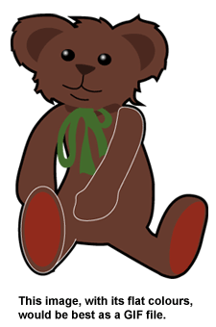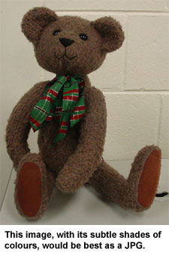
TIFF format: This is a common file format used to save images that need to be read by other imaging devices not just computers. TIFF is an acronym for Tagged Image File Format and is the leading commercial and professional image standard. It is used to archive important images because of its high quality and flexibility.
TIFF file formats attach information in the form of tags which detail the type of data contained in the file. This information can be used by image processing and printing devices to produce consistent colour and resolution without the need for direct computer control.
TIFF images are lossless and use the same compression scheme as GIF formats - LZW. This lossless compression means that a computer can always read back the exact data saved, bit by bit, without data corruption. It is this reliability which makes the TIFF format ideal for archiving master copies of images.
TIFF is a high-quality, universal standard format for saving full colour images. Important documents, images and some photographs should be stored using this format when quality is important than file size. Photographic images when saved using the TIFF format are very large.
While the large file sizes mean plenty of detail, it is not a suitable format for the web. TIFF files have a colour depth of 24 bits making them a great format for all image types.

Other formats
PNG: Stands for Portable Network Graphic used for displaying colour image files on the web. PNG files support transparency like GIF but offer twice the colour depth at 32 bits. Along with improved image compression this format allows special image information to be saved with the file.

PICT: A general purpose image format, PICT can be used for achieving images with large areas of similar colours or borders. This format offers good compression without any loss in quality.

EPS: an acronym for Encapsulated Post Script. This format is used in desktop publishing. The Post Script language is used by printers to output documents that contain images and text.

PDF: This is the native file format created by the software Adobe® Acrobat® and a similar format to EPS. Portable Document Format (PDF) has become the standard format for electronic publishing. Documents using this format can contain images, text and sounds. The file sizes are very small making it suitable for use on the web. PDF files open in the Acrobat reader and appear exactly as the original making the format user friendly, cross-platform, and producing high-quality printouts.

